**PIZZA SALES DATABASE QUERIES**

KPIs

**1. Total Revenue:**

select sum(total_price) as Total_Revenue from pizza_sales;

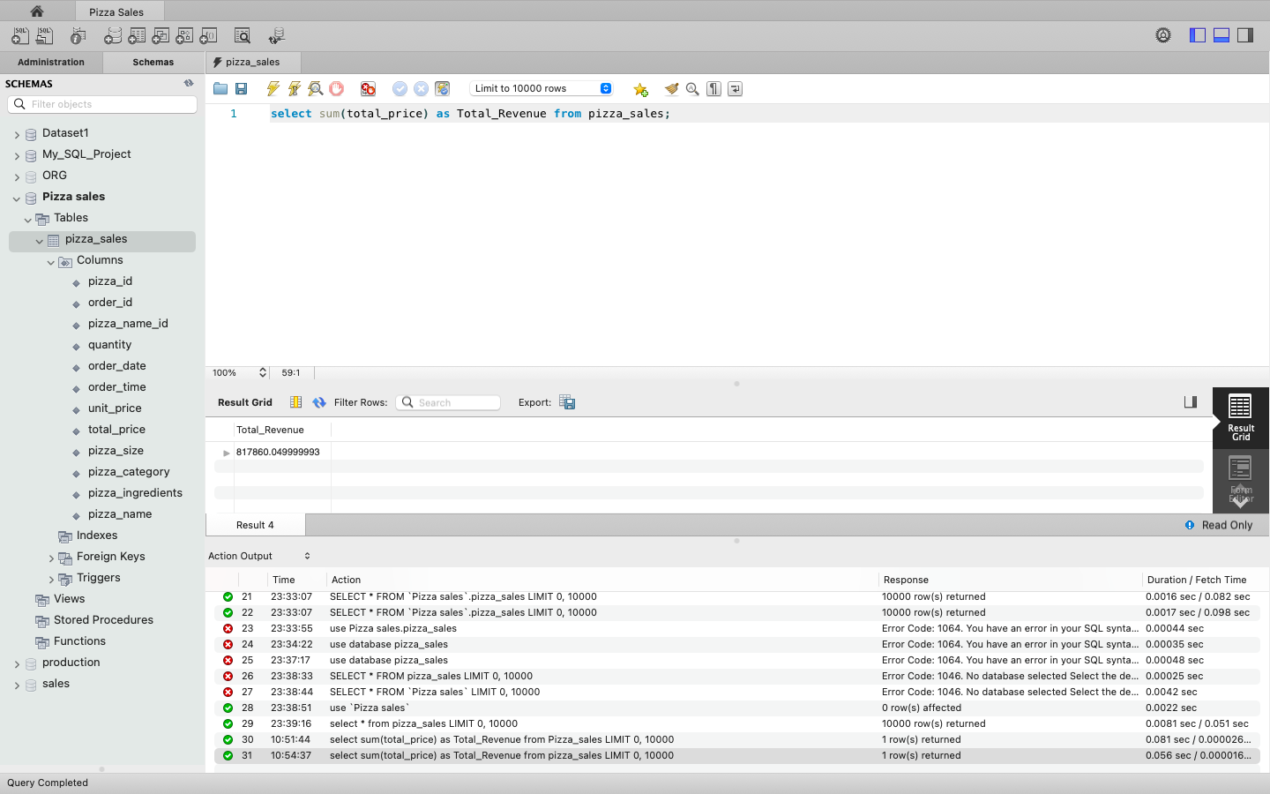

**2. Average Order Value**

select sum(total_price) / count(distinct order_id) as Average_order_value from Pizza_sales;



**3. Total Pizzas Sold**

select sum(quantity) as Total_pizza_sold from Pizza_sales;



**4. Total Orders Placed**

select count(distinct order_id) as Total_orders_placed from Pizza_sales;



**5.Average Pizzas Per Order**

select cast(sum(quantity)/ count(distinct order_id)as decimal(10,2)) as Average_Pizzas_per_Order from Pizza_sales;



**6. Total orders Per WeekDay**

select DAYNAME(STR_TO_DATE(order_date, '%d-%m-%Y')) as Order_day,

count(distinct order_id) as Total_orders from Pizza_sales

group by Order_day;

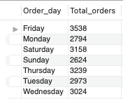

**7. Total Orders Per Month**

select monthname(STR_TO_DATE(order_date, '%d-%m-%Y')) as Month_Name,

count(distinct order_id) as Total_Orders from Pizza_sales

group by Month_Name order by Total_Orders desc;

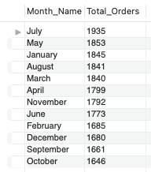

**8. % of Sales by Pizza Category**

select pizza_category as Pizza_category, sum(total_price) as Total_sales,

sum(total_price)*100 / (select sum(total_price) from pizza_sales

where month(str_to_date(order_date, '%d-%m-%y'))= 1) as Percentage_of_total

from Pizza_sales

where month(str_to_date(order_date, '%d-%m-%y'))= 1

group by Pizza_category;

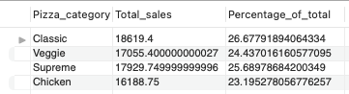

**9. % of Sales by Pizza Size**

select pizza_size as Pizza_size,

cast(sum(total_price) as decimal(10,2)) as Total_sales,

cast(sum(total_price)*100 / (select sum(total_price) from pizza_sales

where month(str_to_date(order_date, '%d-%m-%y'))= 1)as decimal(10,2)) as Percentage_of_total

from Pizza_sales

where month(str_to_date(order_date, '%d-%m-%y'))= 1

group by Pizza_size

order by Percentage_of_total desc;

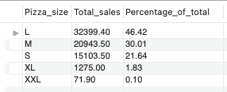

**10. Total Revenue by Pizza Name**

select pizza_name, sum(total_price) as Total_revenue

from Pizza_sales group by pizza_name

order by Total_revenue desc limit 5;

